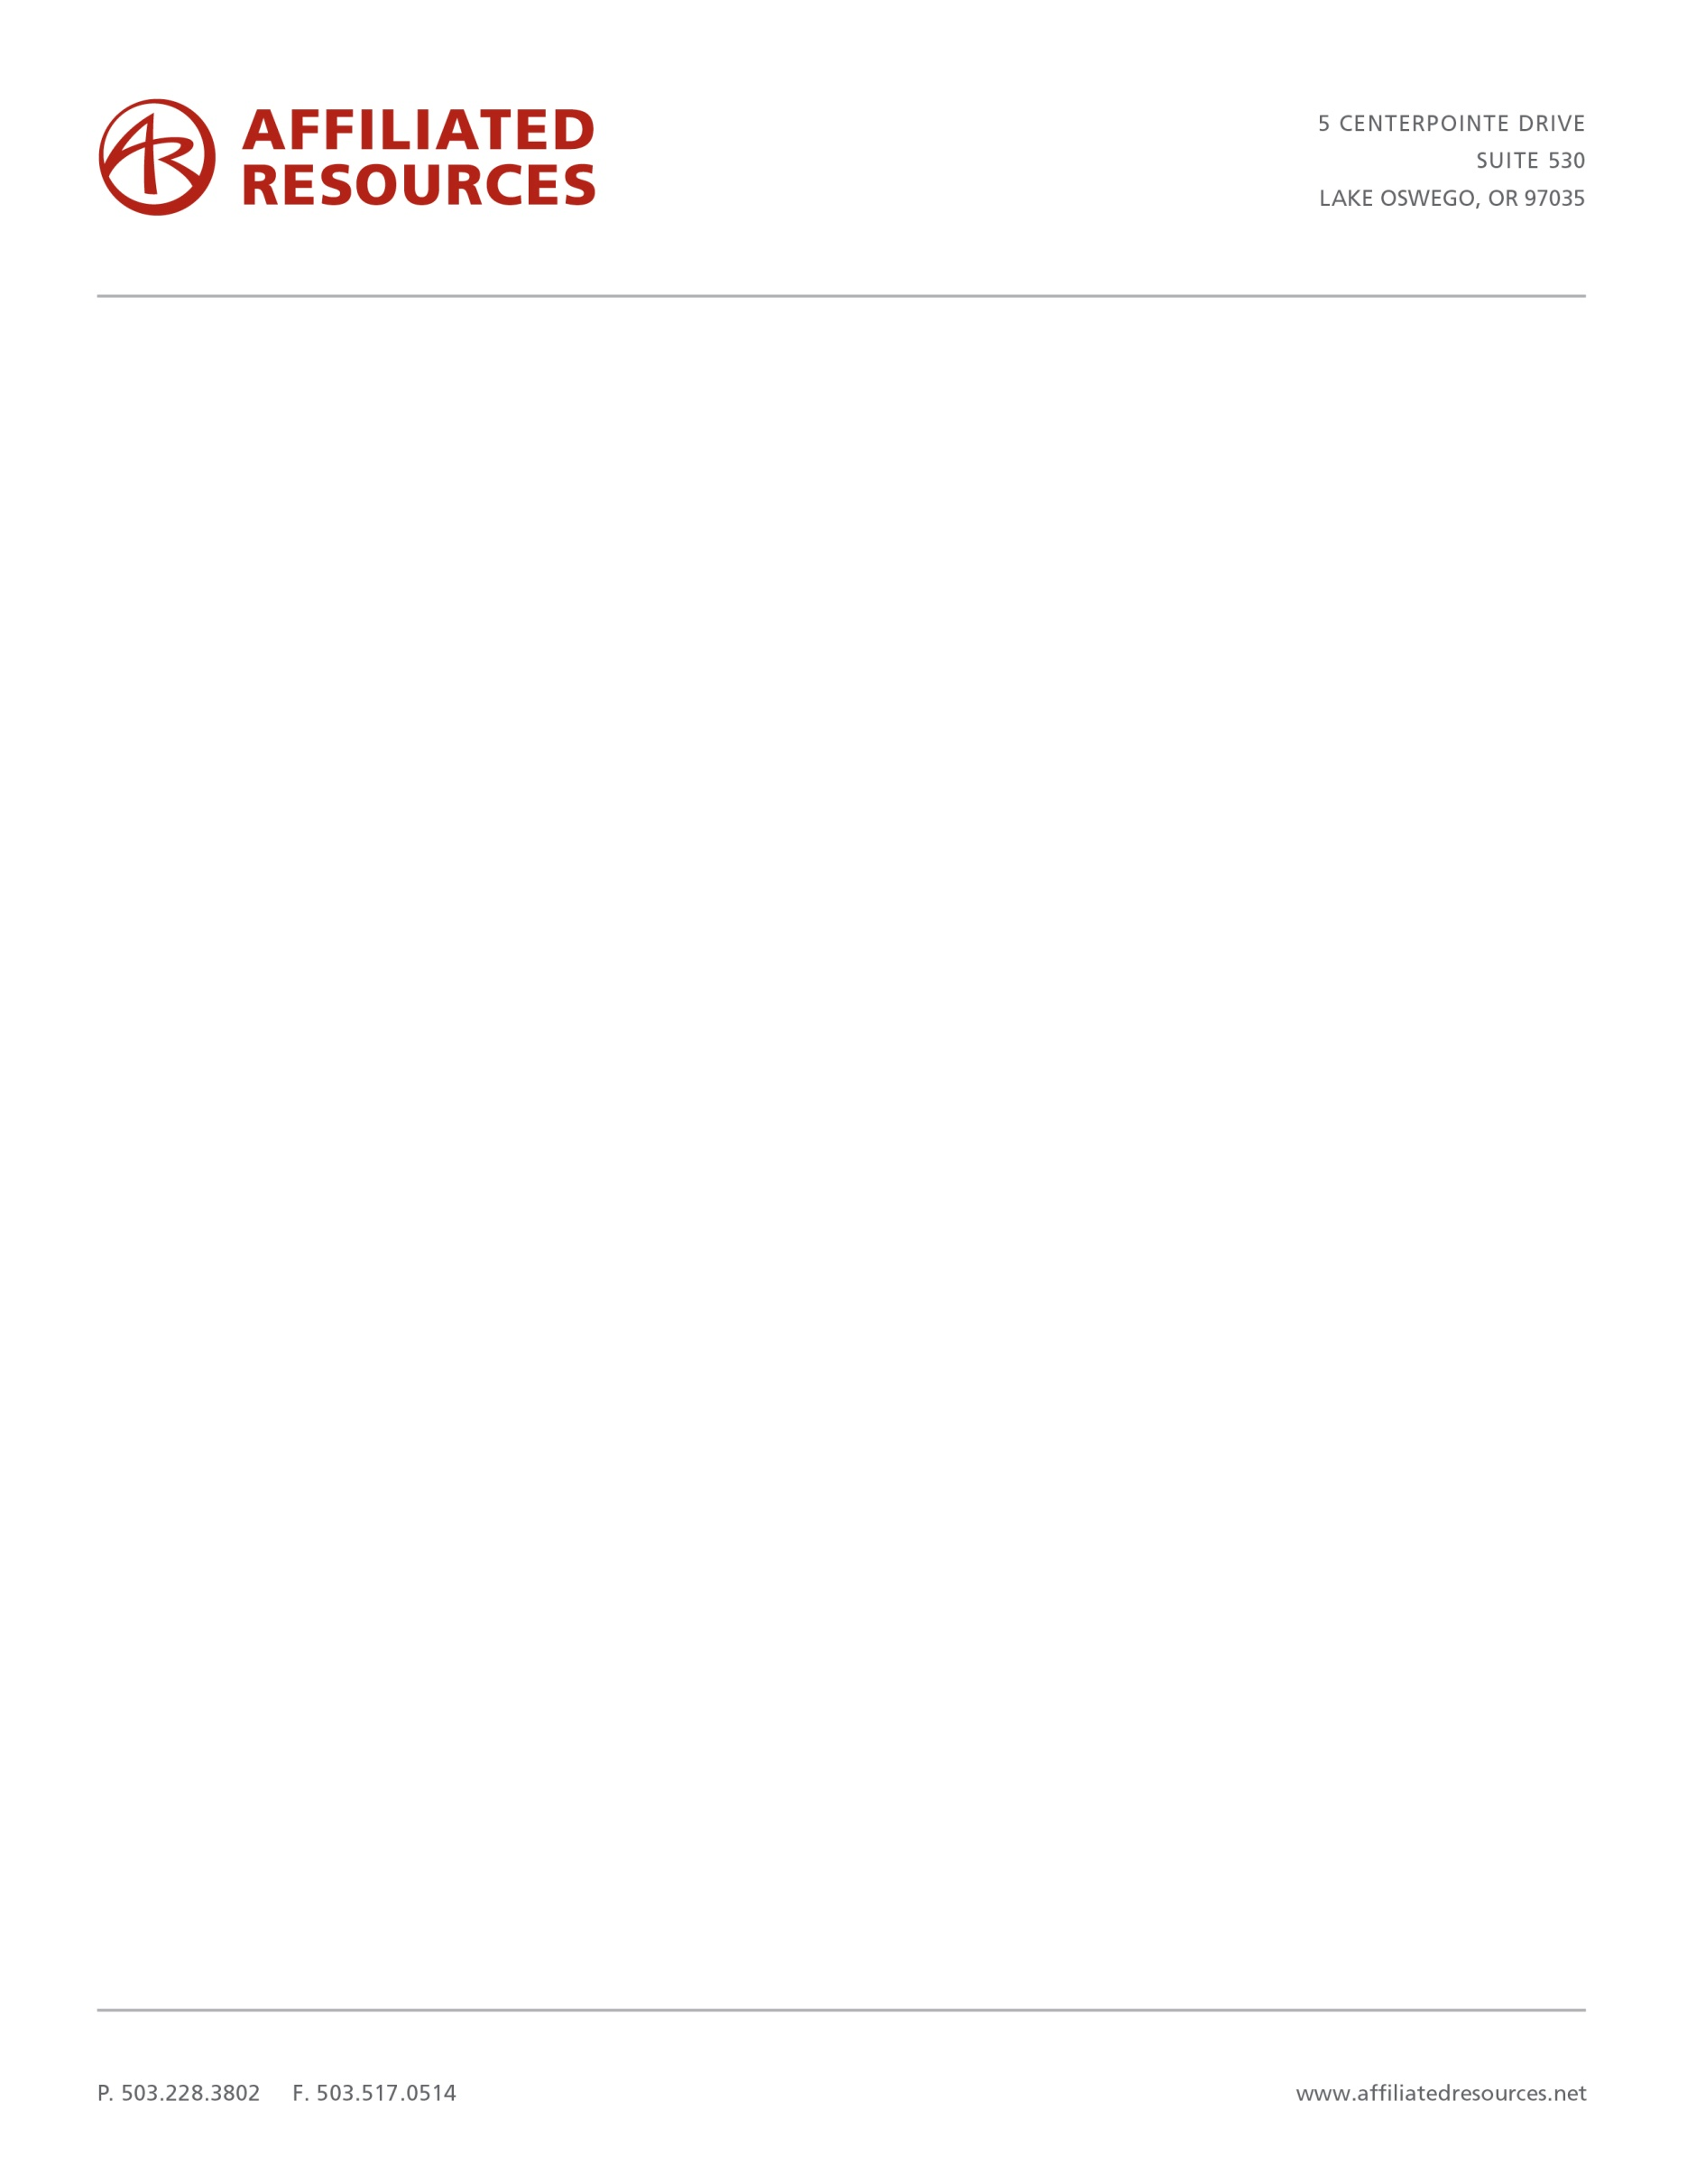

No person or business shall knowingly and intentionally expose an individual to wood dust without first providing a clear and reasonable warning. The warning requirement applies to any company who manufactures, produces, sells, distributes, or otherwise transfers a wood product into the stream of commerce in California.

We strongly encourage you to determine the appropriate steps you must take to comply with the requirements of this regulation, including your communication to your customers. You can find more information about this at <http://oehha.ca.gov/prop65/background/p65plain.html>.

Affiliated Resources provides Safety Data Sheets (SDS) and labels as a download from our website at http://www.affiliatedresources.net/safety.

If you have questions, please contact us at the address listed in the header.

**WARNING**

Drilling, sawing, sanding or machining wood products generates wood dust, a substance known to the State of California to cause cancer. Avoid inhaling wood dust or use a dust mask or other safeguards for personal protection.

Wood products emit chemicals known to the State of California to cause birth defects or other reproductive harm.

**California Health and Safety Code Section 25249.6**

In December 2009, the State of California added wood dust to the list of chemicals that can cause cancer. Since Affiliated Resources ships wood products throughout California, we are required to provide the following warning to our customers:

**IMPORTANT NOTICE**

**CALIFORNIA PROPOSITION 65 CONSUMER RAW WOOD PRODUCT WARNINGS**